|  |  |  |  |
| --- | --- | --- | --- |
| FULL NAME: | DATE: | CYCLE: | SPECIALTY: |

1. Complete the crossword with verbs:

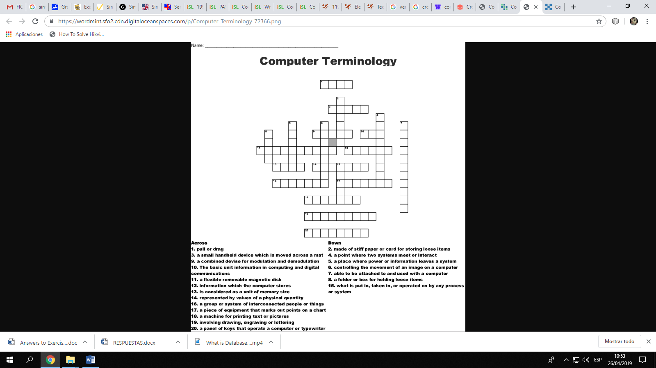

1. Draw
2. Folder
3. 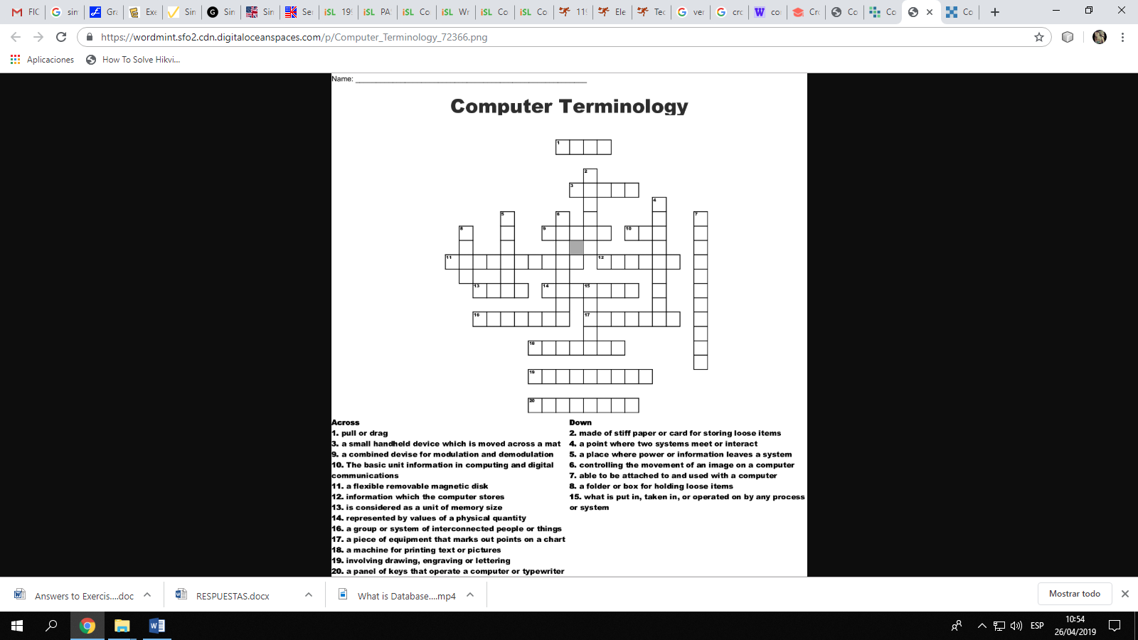File
4. Floppy disk
5. Output
6. Byte
7. Network
8. Printer
9. Keyboard
10. Graphical
11. Mouse
12. Modem
13. Joystick
14. Input
15. Interface
16. Peripherals
17. Plotter
18. Memory
19. Digital
20. Bit

|  |  |  |  |
| --- | --- | --- | --- |
| FULL NAME: | DATE: | CYCLE: | SPECIALTY: |

1. Write sentences in simple past.
2. Janet / click / the mouse →
3. she / type / a password →
4. Nancy / install / not / a program→
5. she / edit / a document →
6. they / minimize / the website →
7. Choose Was or Were:
8. The teacher _______ nice.
9. The students _______very clever.
10. But one student _________in trouble.
11. We ________sorry for him.
12. He _________nice though.
13. Complete the table in simple past.

|  |  |  |
| --- | --- | --- |
| **Affirmative** | **Negative** | **Interrogative** |
| He search a book. |  |  |
|  | He did not install the game. |  |
|  |  | Was she pretty? |

1. Fill in the blanks with the past simple of the verbs in brackets:
2. When I _______ (be) in Japan, I _______ (find) everything very different.
3. Two years ago my parents ___________ (buy) a new computer.
4. Last Summer Peter __________(spend) his holidays playing games on internet.
5. My sister ________ (get) a new job in the computing center.

|  |  |  |  |
| --- | --- | --- | --- |
| FULL NAME: | DATE: | CYCLE: | SPECIALTY: |

Reading Comprehension

The first electronic computers, made in the 1940’s, were large, slow, and very expensive, but in the 1960’s computers made a giant step forward with the invention of transistors. Transistors used the semi-conductor properties of silicon to provide electronic amplification. The problem with the early computers was that the electricity used in the computers passed along wires and valves, and this caused very high temperatures. Because silicon is a semi-conductor, the problem of very high temperatures was solved, and it was possible to reduce the size and cost of computers, and also to make them work much faster with more powerful computers.

Today, a simple microcomputer can process more information more quickly than the famous Harvard Mark I (IBM ’s first computer, made in 1943) which was 55 feet long and 8 feet high and cost millions of dollars.

Answer:

1. When were the first electronic computers made?

.........................................................................................

1. Were they cheap?

.........................................................................................

1. How were the first computers?

..........................................................................................

1. What was the problem with the early computers?

..........................................................................................

1. What important discovery was made in the 1960’s?

..........................................................................................